Personal Emergency Evacuation Plan (PEEP) Information

Approved by: | Ryefield Primary LGB | Date: 06/03/2023
Last reviewed on: | 07/03/2023
Next review due by: | March 2024

Evacuation of Disabled Persons
PERSONAL EMERGENCY EVACUATION PLANS (PEEPs)

Thinking About PEEPs and Persons With A Disability

People with a disability are at a disadvantage generally, but particularly in an emergency.
There are 4 main scenarios that a person with a disability can experience:

- Unaware of alarm or emergency situation
- Unaware of how to react
- Aware, but unable to react
- Aware, but hampered

Some types of disability

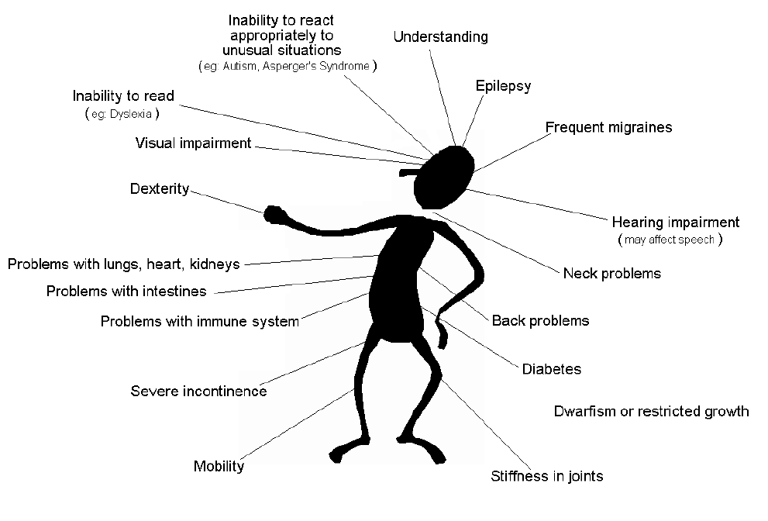

How could a disability affect somebody in an emergency?

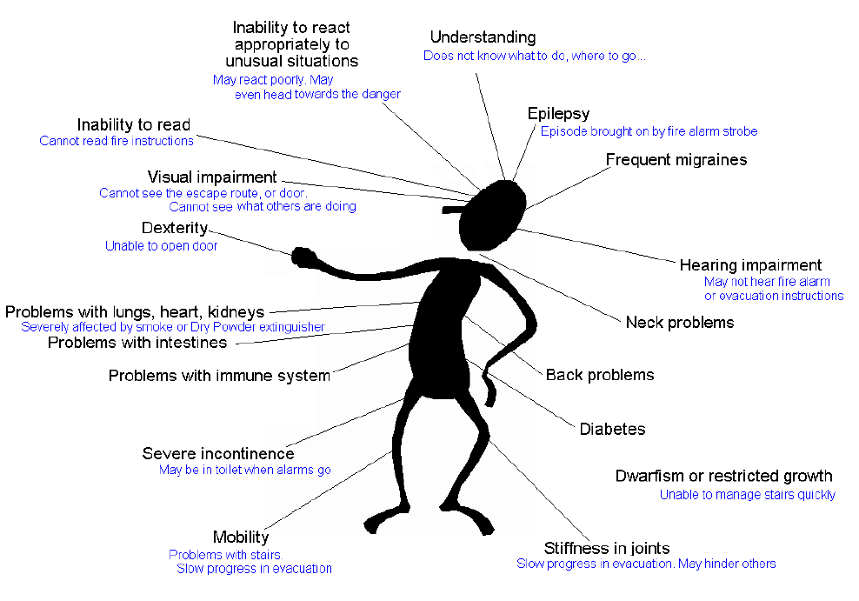

Unaware of alarm or emergency situation
• Blind – unable to see the route or obstacles in the way. May be particularly affected by alarms,
especially in terms of stress, heart-rate, etc
• Deaf - Unable to hear alarms, or unable to hear instructions & guidance
• Deaf-blind – both of the above
Unaware of how to react
• Mental Health problem - May go in any direction, even towards the danger. May react in an
extremely unusual way.
• Learning Difficulty - May have little or no understanding of the danger, or where to go.
Aware, but unable to react
• Mobility problems - May be very slow. May be unable to use stairs
• Breathing difficulties - Slow pace, frequent stops. May be easily overcome by smoke or
extinguishant
Aware, but hampered
• Visual impairment - eg: retinitis-pigmentosa (tunnel-vision), macular degeneration. - May
have difficulty seeing obstacles or stairs. Will be slowed down when trying to operate the
exit mechanism
• Epileptic - May go into seizure at the sight of a strobe

PEEPs should be created as part of the fire strategy and should consider the needs of the disabled
persons using the building, the building design and construction, the fire strategy, and the local fire
procedures.

Disability, Evacuation and the Law

The Regulatory Reform (Fire Safety) Order 2005 places a legal duty on those with ‘responsibility’ over
the management and operation of premises to provide adequate means for emergency escape in the
event of fire for all building occupants. The same rights in law apply to those members of staff or
visitors in a building who for whatever reason suffer from some degree of impairment that puts them at
a disadvantage in the event of an emergency. The Order requires fire risk assessments to be
undertaken as the means by which a ‘responsible person’ can identify and manage fire risks. The
provision of facilities for the safe emergency evacuation of those with impairments should be considered an
important part of the fire risk management process.

What is a Mobility Impairment?

The degree to which an individual is affected by a mobility impairment, and the extent that this
constitutes a life risk that may be unique to that individual’s circumstance. A mobility impairment
definition can be applied to any individual who is unable, or finds it difficult to move over the potential
evacuation distance without the assistance or others, or at such a pace that would impede others
escaping at a normal speed. In effect, the definition can be extended beyond the wheelchair user to
elderly persons, those with breathing difficulties, those with temporary conditions such as pregnancy, or
those injuries affecting their mobility. It could also affect those with a visual impairment, who move
slowly because they cannot easily see the means of escape. In short, any individual who is unable to
evacuate with the main body of able-bodied occupants.

Other Disabilities
Others disabilities may also affect a person’s ability to evacuate as quickly as required. These include,
but are not limited to:
Hearing impairment, where somebody is unable to hear the fire alarm sounders, or is unable to hear
guidance instructions given by members of staff, either with or without the added interference of alarm
sounders;
Learning difficulty, where somebody cannot understand what is being told to them, does not
understand the gravity of the situation, or moves in unpredictable directions;
Poor Mental Health, where a person may intentionally or otherwise act in an unpredictable manner
and possibly impede the progress of others.

What are the Fire Risk Moderating Options?
Access and facilities for those with disabilities is required by all service providers and employers. In
meeting the freedom of access laws, the potential exists to contravene fire safety law and this is where
fire risk assessment plays its part. Strategies and procedures associated with managing the safe
evacuation of mobility impaired persons involve physical fire safety provisions and fire safety
management provisions. Physical provisions need to be suitable for all classifications of mobility
impairment. They usually consist of a combination of evacuation lift provision and protected stairways
with carry chairs, both provided with refuges to protect occupants from the effects of fire whilst they wait
for assistance. Refuges need to be clearly recognisable and if we are to ask a mobility impaired person
to wait whilst others evacuate, we must ensure that a means for these persons to communicate with
the building management is available – such as by means of a 2-way radio.

Fire Safety Management of Mobility Impaired Persons
It is clear that occupants with mobility impairments may need assistance to safely evacuate. It is the
responsibility of premises managers to ensure that the uniqueness of an individual’s mobility
impairment is properly coordinated with the physical provisions for their escape. The system normally
applied is known as the Personal Emergency Evacuation Plan (PEEP). It is a system that constitutes a
contract between the individual and the organisation that sets expectations from the individuals’ point of
view concerning what support he or she can expect and, from the organisations perspective, applies
reasonable conditions on occupation.
Where possible, the PEEP should be developed in conjunction with the individual (or parent and child,
if the plan is for a child) to agree what action will be taken. For example, a person with a visual
impairment may need to be escorted from the premises in case of a fire and a staff member should be
nominated for this activity.
Once a PEEP has been established, arrangements should be put in place to ensure that these are
practiced and it is recommended that these are carried out separately to the standard test evacuation.
The needs of the individual should be considered and therefore it may be inappropriate for the
individual to be involved in the test evacuation. In these cases, a volunteer to take their place should
be identified.

Personal Emergency Evacuation Plan (PEEP)
Aim
The aim of a PEEP is to provide people who cannot get themselves out of a building unaided with the
necessary information and assistance to be able to manage their escape to a place of safety and to
ensure that the correct level of assistance is always available.

Safe Routes
A PEEP should contain details of the necessary escape route(s). Clear unobstructed gangways and
floor layouts should be considered at the planning stage.

Deaf and Hearing Impaired persons
Generally, most deaf people alongside hearing peers will not require special equipment, providing they have
been made aware of what to do in the event of a fire. They will be able to see and understand the behaviour
of those around them.

Training
To be effective, any Emergency Plan depends on the ability of staff to respond efficiently. Staff will
therefore receive instructions, practical demonstrations and training appropriate to their responsibilities.
This may include some or all of the following elements:
• Fire drills for staff, services users, regular visitors, etc.
• Specific training/instruction for nominated members of staff e.g. Fire Wardens
• Specific training/instruction in the use of Fire Extinguishers etc.

Personal Emergency Evacuation Plan
Name ___________________________________________________
Class ___________________________________________________
Building ___________________________________________________
Floor ___________________________________________________

Awareness of Procedure
The disabled person is informed of a fire evacuation by (circle agreed procedure):
Teacher who is working with the disabled person
Other (please specify)_______________________________________________________
Designated Assistance:
(The following people have been designated assist me to evacuate the building in an emergency).
Name _____________________________________________________________
Usual Location of Work___________________________________________
Name _____________________________________________________________
Usual Location of Work________________________________________________
Methods of Assistance:
(e.g.: Transfer procedures, methods of guidance, etc.)
_________________________________________________________________________
_________________________________________________________________________
_________________________________________________________________________
Equipment Provided (including means of communication):
_________________________________________________________________________
_________________________________________________________________________
_________________________________________________________________________
(A step by step account beginning from the first alarm)
______________________________________________________________________________
______________________________________________________________________________
______________________________________________________________________________
______________________________________________________________________________
______________________________________________________________________________
Safe Route(s):
______________________________________________________________________________
______________________________________________________________________________
______________________________________________________________________________
Date of agreement: _________________________
Signed by: ______________________________________________

