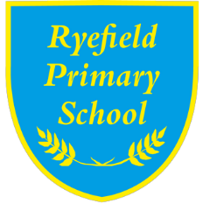

Remote Education Policy
2020-2021

Approved by: | [K Farrell Chair of Governors] | Date: [ 12/10/2020]
Last reviewed on: | [ 12/10/2020]
Next review due by: | [ Autumn 2021]

Contents
1. Statement of intent 2
2. Aims 2
3 .Who is this policy applicable to? 2
4. Content and Tools to Deliver This Remote Education Plan 2
5. Home and School Partnership 3
6. Roles and responsibilities 3
7. Links with other policies and development plans 6
Appendices: 7
Appendix 1: Template letter to confirm arrangements for home learning: English 8
Appendix 2: Template letter to confirm arrangements for home learning: Polish 11
Appendix 3: Template letter to confirm arrangements for home learning: Arabic 14

1. Statement of intent
Ryefield Primary has always strived to be creative, innovative and support our parents/children in the best way possible to make learning purposeful and holistic. Our strategy for remote learning continues this.

2. Aims
This Remote Education Policy aims to:
- Ensure consistency in the approach to remote learning for all pupils (Inc. SEND) who aren’t in school through use of quality Online and offline resources and teaching videos
- Provide clear expectations members of the school community with regards to delivery high quality interactive remote learning
- Include continuous delivery of the school curriculum, as well as support of Motivation, Health and Well-Being and Parent support
- Consider continued education for staff and parents (e.g. CPD, Supervision and Meet the Teacher)
- Support effective communication between the school and families and support attendance

3 .Who is this policy applicable to?
- A child (and their siblings if they are also attending Ryefield Primary) is absent because they are awaiting test results and the household is required to self-isolate. The rest of their school bubble are attending school and being taught as normal.
- A child’s whole bubble is not permitted to attend school because they, or another member of their bubble, have tested positive for Covid-19.
Remote learning will be shared with families when they are absent due to Covid related reasons and not to all at start of week

4. Content and Tools to Deliver This Remote Education Plan
Resources to deliver this Remote Education Plan include:
- Online tools for EYFS KS1 KS2: Education City, Flash Academy, Google, Lexia, LGfL resources, Spelling Shed, Times Tables Rock Stars, Zoom
- Use of Recorded video (or Live Video if used) for Start Day registration, instructional videos and assemblies
- Phone calls home
- Printed learning packs
- Physical materials such as story books and writing tools
- Use of BBC Bitesize, and National Oak Academy,
The detailed remote learning planning and resources to deliver this policy can be found here:

5. Home and School Partnership

Ryefield Primary School is committed to working in close partnership with families and recognises each family is unique and because of this remote learning will look different for different families in order to suit their individual needs.
Ryefield Primary School will provide a refresher online training session and induction for parents on how to use Google Classroom as appropriate and where possible, provide personalised resources.
Where possible, it is beneficial for young people to maintain a regular and familiar routine. Ryefield Primary School would recommend that each ‘school day’ maintains structure
We would encourage parents to support their children’s work, including finding an appropriate place to work and, to the best of their ability, support pupils with work encouraging them to work with good levels of concentration.
Every effort will be made by staff to ensure that work is set promptly. Should accessing work be an issue, parents should contact school promptly and alternative solutions may be available. These will be discussed on a case-to-case basis.
All parents and guardians sign an ‘E-Safety’ statement which includes the agreement that parents will monitor and supervise their children’s use of electronic devices.

6. Roles and responsibilities
Teachers
Ryefield Primary School will provide a refresher training session and induction for new staff on how to use Google Classroom.
When providing remote learning, teachers must be available between their contracted hours of work.
If they are unable to work for any reason during this time, for example due to sickness or caring for a dependent, they should report this using the normal absence procedure.
When providing remote learning, teachers are responsible for:
- Setting work:
  - Teachers will set work for the pupils in their classes. This includes those responsible for streamed groups in Year 5 and 6
  - The work set should follow the usual timetable for the class had they been in school, wherever possible
  - On a weekly basis, work will be shared, uploaded and made available to parents. The delivery day will be every Friday. Google Classroom and Wonde will be the primary mechanism for delivery.
- Providing feedback on work:
  - During quarantine and local lockdown, whole class feedback sheets shall be used to address common misconceptions and celebrate excellence.
  - Teacher’s may also use the chat function within Google Classroom to provide more detailed feedback.
- Keeping in touch with pupils who aren’t in school and their parents:
  - If there is a concern around the level of engagement of a pupil/s parents should be contacted via phone to assess whether school intervention can assist engagement. Teachers must not use their personal devices to make telephone contact with parents.
  - All parent/carer emails should come through the school admin account (ryefield.enquiries@...)
  - Any complaints or concerns shared by parents or pupils should be reported to a member of SLT– for any safeguarding concerns, refer immediately to the DSL via CPOMS.
Teaching Assistants
Teaching assistants must be available during their contracted hours.
If they are unable to work for any reason during this time, for example due to sickness or caring for a dependent, they should report this using the normal absence procedure.
During the school day, teaching assistant must complete tasks as directed by either their line manager, or a member of the SLT.

Senior Leaders
Alongside any teaching responsibilities, senior leaders are responsible for:
- Co-ordinating the remote learning approach across the school inc daily monitoing of engagement.
- Monitoring the effectiveness of remote learning – explain how they’ll do this, such as through regular meetings with teachers and subject leaders, reviewing work set or reaching out for feedback from pupils and parents
- Monitoring the security of remote learning systems, including data protection and safeguarding considerations

Designated safeguarding lead
The DSL is responsible for managing and dealing with all safeguarding concerns. For further information, please see the Safeguarding and Child Protection Policy.
IT Technicians
IT technicians are responsible for:
- Fixing issues with systems used to set and collect work
- Helping staff with any technical issues they’re experiencing
- Reviewing the security of remote learning systems and flagging any data protection breaches to the data protection officer
- Assisting pupils and parents with accessing the internet or devices
The SENCO
Liaising with the ICT technicians to ensure that the technology used for remote learning is accessible to all pupils and that reasonable adjustments are made where required.
- Ensuring that pupils with EHC plans continue to have their needs met while learning remotely, and liaising with the headteacher and other organisations to make any alternate arrangements for pupils with EHC plans and IHPs
- Identifying the level of support

The School Operations Manager
- Ensuring value for money when arranging the procurement of equipment or technology.
- Ensuring that the school has adequate insurance to cover all remote working arrangements.

Pupils and parents
Staff can expect pupils learning remotely to:
- Complete work to the deadline set by teachers
- Seek help if they need it, from teachers
- Alert teachers if they’re not able to complete work
Staff can expect parents with children learning remotely to:
- Make the school aware if their child is sick or otherwise can’t complete work
- Seek help from the school if they need it – if you know of any resources staff should point parents towards if they’re struggling, include those here
- Be respectful when making any complaints or concerns known to staff

Governing Body
The governing body is responsible for:
- Monitoring the school’s approach to providing remote learning to ensure education remains as high quality as possible
- Ensuring that staff are certain that remote learning systems are appropriately secure, for both data protection and safeguarding reasons

7. Links with other policies and development plans
This policy is linked to our:
- Safeguarding
- Behaviour policy
- Child protection policy
- Data protection policy and privacy notices
- Online safety acceptable use policy

Appendices:
Appendix 1: Template letter to confirm arrangements for home learning: English. (p.8)
Appendix 2: Template letter to confirm arrangements for home learning: Polish. (p 10)
Appendix 3: Template letter to confirm arrangements for home learning: Arabic. (p14)

Appendix 1: Template letter to confirm arrangements for home learning: English
Dear parents and carers,

Earlier today, we notified you that we have been advised by Public Health England that your child has to stay at home and self-isolate. You are being asked to do this to reduce the further spread of COVID 19 to others in the community.

Therefore, your child is required to learn from home. This letter will detail the arrangements the school has put in place for home learning, some of which will be familiar to you.
Your child has already been provided with a series of paper based materials to assist you if you are unable to access a computer. If you have lost or mislaid the workbook then please contact the school office. Further learning packs are available here. In addition, your child will have further resources made available via Google Classroom. These may include the following:
- Grammar mat
- 200 High Frequency Words that all pupils must know!
- Common Exception Words
- Reading support mat designed by Mrs Hope
- Spelling rules.
- Multiplication grid and 1-12 learn by rote sheet.
- How to teach/instil resilience guidance sheet
- A covering letter explaining how to use these resources

The school has a dedicated section of its website that contains all the necessary links needed to access our online resources. Click here.

####### will update the resources available within Education City. These lessons can be accessed via the Wonde Emoji password that was issued prior to lockdown.

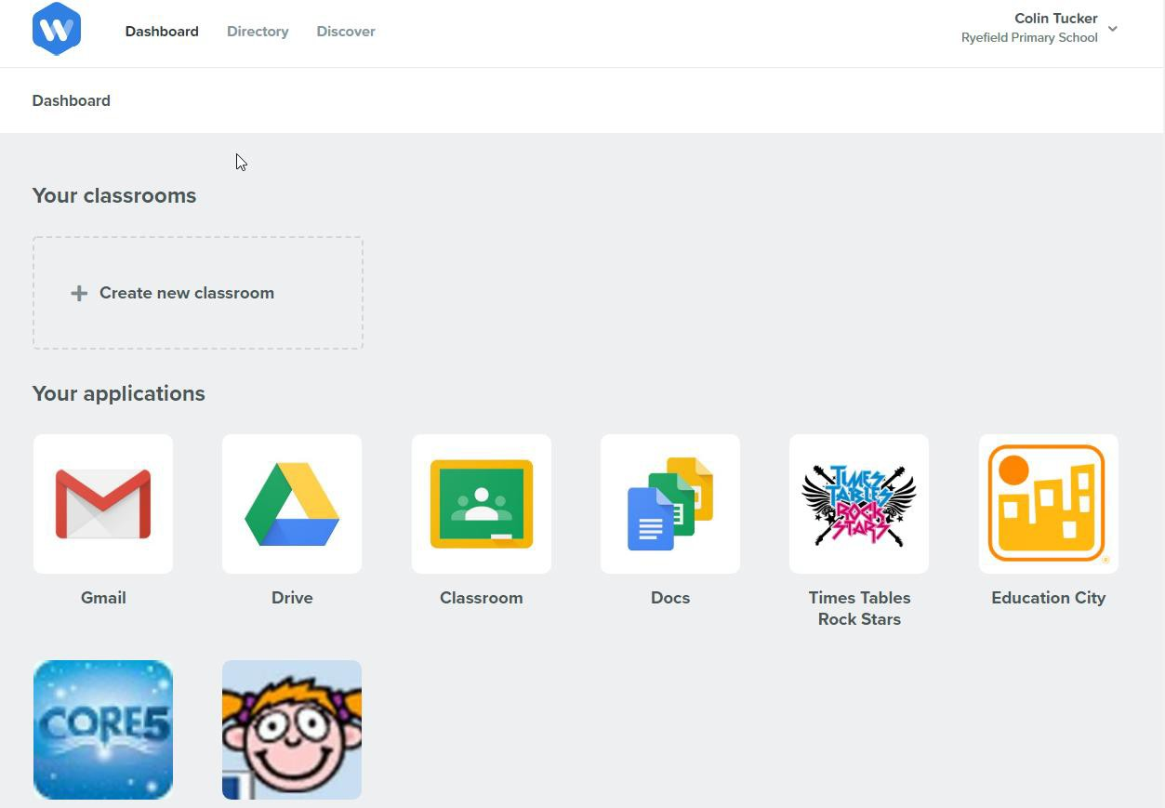

If you have mislaid your child’s details, or have recently joined the school, please contact the school office as soon as possible.

In addition to all of these existing resources, we expect pupils to follow the daily materials, which have been made available via the National Oak Academy. Click here to access the resources:
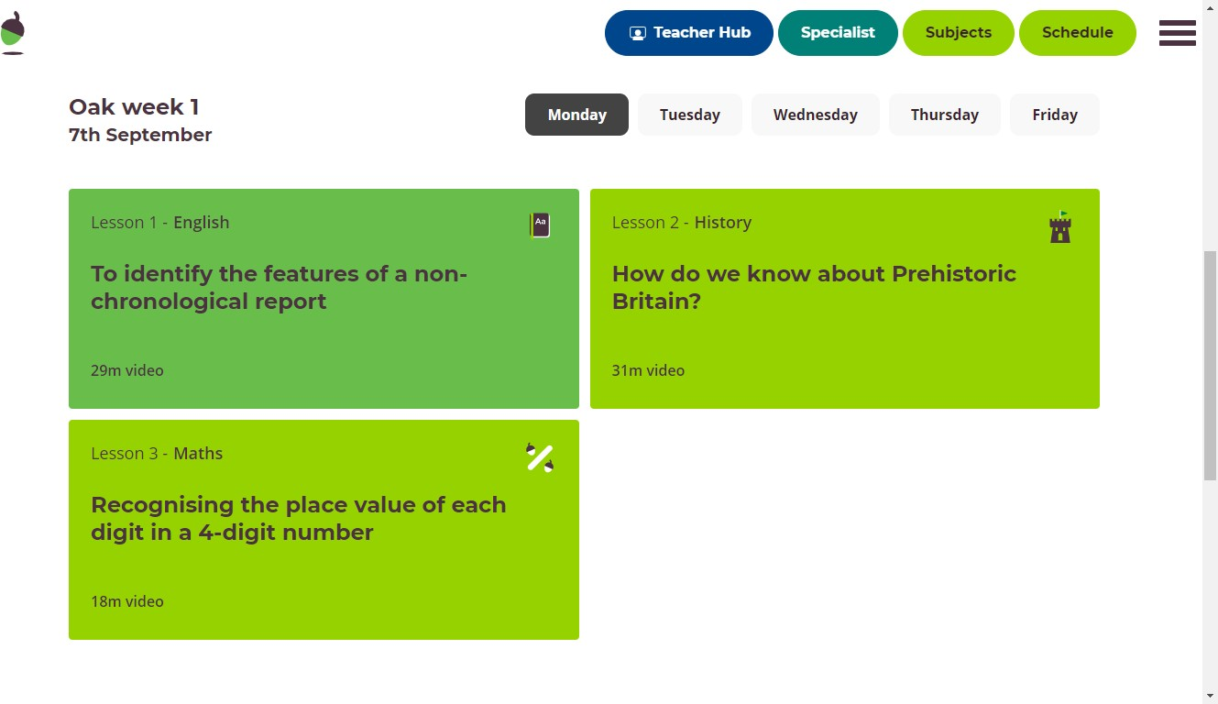

You will see that each year group have three daily lessons, which will support and consolidate prior learning. We recommend that – if pupils have not accessed this site before – then your child should start at Week 1 and follow the daily schedule.

We would encourage a basic daily timetable of the following:

- Daily reading x 20-30 minutes
- Daily Rock Star Times Tables x 10 – 15 minutes
- Daily Oak National Academy schedule of x 3 sessions
- Daily use of Education City – pupils can choose their learning pathway
- Use of paper based resources.

We know that this is not a substitute for a teacher; however, we believe that our augmented learning provision will go some way to filling that gap and providing greater continuity between home and school.

Throughout this process, we have tried to factor in flexibility that allows parents and pupils to fit the tasks around home routines. Should you have any problem accessing the resources, please contact the school office.

Sincerely

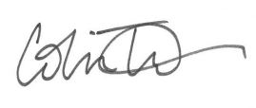

Appendix 2: Template letter to confirm arrangements for home learning: Polish
Drodzy rodzice i opiekunowie,

Wcześniej w dniu dzisiejszym powiadomiliśmy Cię, że zostaliśmy poinformowani przez Public Health England, że Twoje dziecko musi pozostać w domu i wyizolować się. Jesteś o to proszony, aby to zrobić w celu zmniejszenia dalszego rozprzestrzeniania się COVID 19 na innych w społeczności.

Jeśli dziecko ma się dobrze pod koniec 14-dniowego okresu samotności, może wrócić do szkoły. Obecnie dziecko jest zobowiązane do nauki w domu. W tym piśmie zostaną wyszczególnione ustalenia, jakie szkoła wprowadziła w zakresie nauki w domu, a niektóre z nich będą Ci znane.

Twoje dziecko otrzymało już serię materiałów papierowych, które pomogą Ci w przypadku braku dostępu do komputera. Jeśli zgubiłeś lub zgubiłeś zeszyt ćwiczeń, skontaktuj się z sekretariatem szkoły. Dodatkowe pakiety do nauki na rok 4 są dostępne tutaj. Ponadto Twoje dziecko będzie miało dodatkowe zasoby udostępnione w Google Classroom. Mogą to być następujące:
• Mata gramatyczna
• 200 słów o wysokiej częstotliwości, które wszyscy uczniowie muszą znać!
• Często używane wyjątki
• Mata do czytania zaprojektowana przez panią Hope
• Zasady wymowy.
• Siatka mnożenia i 1-12 ucz się na pamięć.
• Jak uczyć / zaszczepiać arkusz ze wskazówkami dotyczącymi odporności
• List motywacyjny wyjaśniający, jak korzystać z tych zasobów

Szkoła posiada specjalną sekcję na swojej stronie internetowej, która zawiera wszystkie niezbędne linki potrzebne do uzyskania dostępu do naszych zasobów online. Kliknij tutaj.

####### będzie aktualizować zasoby dostępne w ramach Education City. Do tych lekcji można uzyskać dostęp za pomocą hasła Wonde Emoji, które zostało wydane przed zablokowaniem.

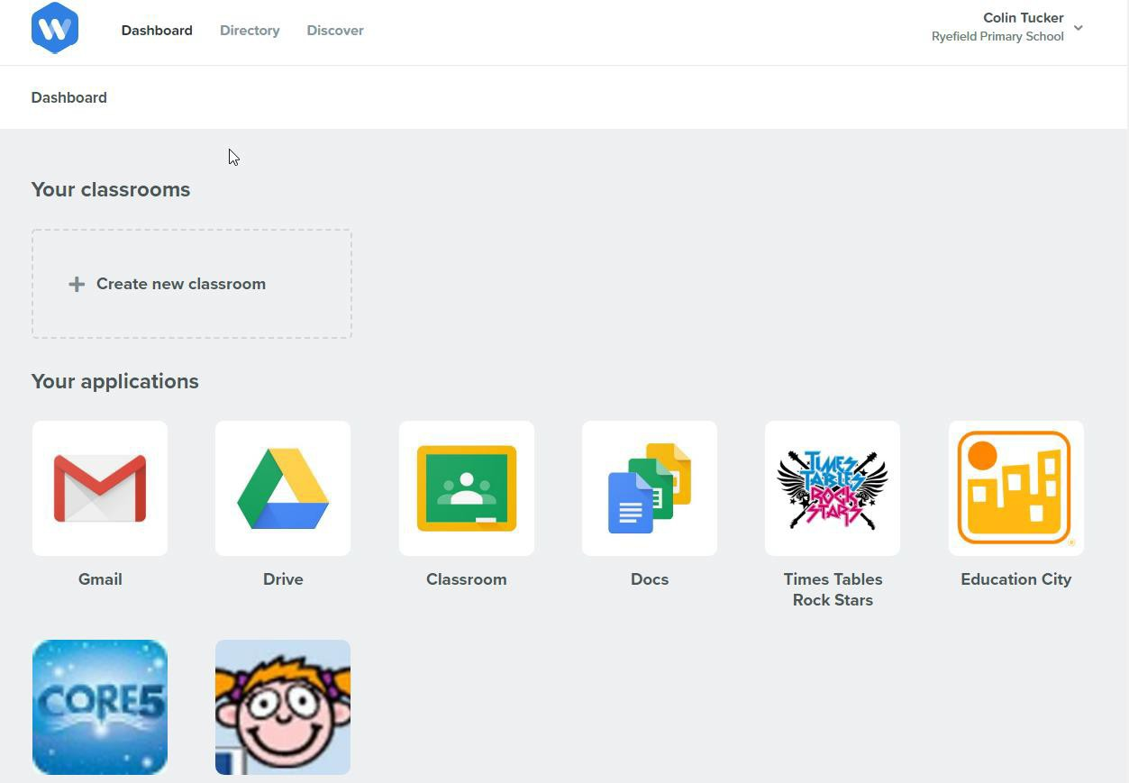

Jeśli źle podałeś dane swojego dziecka lub niedawno dołączyłeś do szkoły, skontaktuj się jak najszybciej z biurem szkoły.

Oprócz tych wszystkich istniejących zasobów oczekujemy, że uczniowie będą śledzić codzienne materiały, które zostały udostępnione za pośrednictwem National Oak Academy. Kliknij tutaj, aby uzyskać dostęp do tych materiałów:
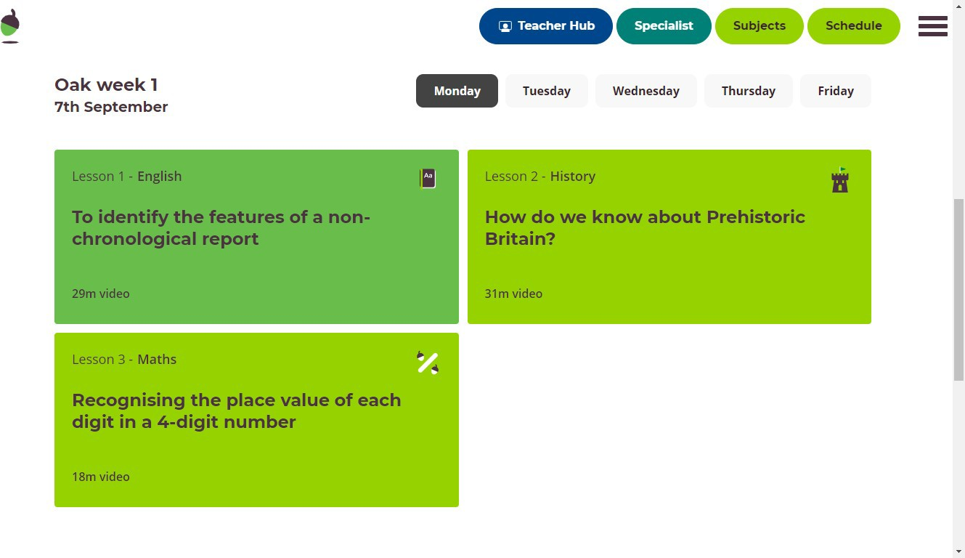

Zobaczysz, że każdego roku grupa ma trzy lekcje dziennie, które wspierają i utrwalają wcześniejszą naukę. Zalecamy, aby - jeśli uczniowie nie mieli wcześniej dostępu do tej strony - dziecko rozpoczęło naukę w pierwszym tygodniu i postępowało zgodnie z planem dnia.

Zachęcamy do korzystania z podstawowego dziennego rozkładu jazdy:

- Dzienny odczyt x 20-30 minut
- Daily Rock Star Times Tables x 10 - 15 minut
- Daily Oak National Academy harmonogram x 3 sesje
- Codzienne korzystanie z Miasta Edukacji - uczniowie mogą wybrać swoją ścieżkę edukacyjną
- Korzystanie z zasobów papierowych.

Wiemy, że nie jest to zastępstwo dla nauczyciela; wierzymy jednak, że nasza oferta rozszerzonej nauki w pewnym stopniu wypełni tę lukę i zapewni większą ciągłość między domem a szkołą.

W trakcie tego procesu staraliśmy się uwzględnić elastyczność, która pozwala rodzicom i uczniom na dopasowanie się do zadań związanych z rutyną domową. W razie jakichkolwiek problemów z dostępem do zasobów, prosimy o kontakt z biurem szkoły.

Z poważaniem

Appendix 3: Template letter to confirm arrangements for home learning: Arabic
،
في وقت سابق من اليوم ، أبلغناكم بأن هيئة الصحة العامة في إنجلترا قد أبلغتنا أن طفلك يجب أن يبقى في المنزل وأن يعزل عن نفسه. يُطلب منك القيام بذلك للحد من انتشار COVID 19 بشكل أكبر للآخرين في المجتمع.

إذا كان طفلك بصحة جيدة في نهاية فترة 14 يومًا من العزلة الذاتية ، فيمكنه العودة إلى المدرسة. في الوقت الحالي ، يتعين على طفلك التعلم من المنزل. ستوضح هذه الرسالة بالتفصيل الترتيبات التي وضعتها المدرسة للتعلم المنزلي ، والتي سيكون بعضها مألوفًا لك.
لقد تم بالفعل تزويد طفلك بسلسلة من المواد الورقية لمساعدتك إذا كنت غير قادر على الوصول إلى جهاز كمبيوتر. إذا فقدت أو أضعت كتيب العمل ، فيرجى الاتصال بمكتب المدرسة. حزم التعلم الإضافية للعام 4 متوفرة هنا. بالإضافة إلى ذلك ، سيتم توفير المزيد من الموارد لطفلك عبر Google Classroom. قد تشمل هذه ما يلي:
• حصيرة القواعد
• 200 كلمة عالية التردد يجب على جميع التلاميذ معرفتها!
• كلمات الاستثناء الشائعة
• حصيرة داعمة للقراءة من تصميم السيدة هوب
• قواعد الإملاء.
• شبكة الضرب و1-12 تعلم عن طريق ورقة عن ظهر قلب.
• كيفية تعليم / غرس ورقة إرشادية حول المرونة
• خطاب تغطية يشرح كيفية استخدام هذه المواردهنا.

####### ستعمل على تحديث الموارد المتاحة داخل المدينة التعليمية. يمكن الوصول إلى هذه الدروس عبر كلمة مرور Wonde Emoji التي تم إصدارها قبل الإغلاق.

إذا كنت قد أضعت تفاصيل طفلك ، أو انضممت مؤخرًا إلى المدرسة ، فيرجى الاتصال بمكتب المدرسة في أقرب وقت ممكن.

بالإضافة إلى كل هذه الموارد الموجودة ، نتوقع من الطلاب متابعة المواد اليومية التي

تم توفيرها عبر أكاديمية أوك الوطنية. انقر هنا للوصول إلى الموارد:

سترى أن كل مجموعة سنوية لديها ثلاثة دروس يومية ستدعم وتوطد التعلم السابق. نوصي - في حالة عدم دخول التلاميذ إلى هذا الموقع من قبل - يجب أن يبدأ طفلك في الأسبوع الأول ويتبع الجدول اليومي.

نشجع على وضع جدول زمني يومي أساسي لما يلي:

• القراءة اليومية × 20-30 دقيقة
• جداول روك ستار تايمز اليومية × 10 - 15 دقيقة
• جدول أكاديمية أوك الوطنية اليومية من × 3 جلسات
• الاستخدام اليومي للمدينة التعليمية - يمكن للتلاميذ اختيار مسار التعلم الخاص بهم
• استخدام الموارد الورقية.

نحن نعلم أن هذا ليس بديلاً عن المعلم ؛ ومع ذلك ، نعتقد أن توفير التعلم المعزز لدينا سيقطع شوطا ما في سد هذه الفجوة وتوفير قدر أكبر من الاستمرارية بين المنزل والمدرسة.

خلال هذه العملية ، حاولنا مراعاة المرونة التي تسمح للآباء والتلاميذ بمواءمة المهام المتعلقة بالروتين المنزلي. إذا واجهتك أي مشكلة في الوصول إلى الموارد ، فيرجى الاتصال بمكتب المدرسة.

بإخلاص

