Aims

BEHAVIOUR POLICY

A good behaviour management policy is at the center of teaching and learning and underpins responsible membership of the school community. As such, it makes a significant impact to the school’s aims:

- To provide a challenging, stimulating, caring and safe environment where all children are encouraged to develop to their full potential
- To encourage independence, responsibility, self-discipline and pride in our achievements and our school
- To enable all children to be granted respect irrespective of age, race, creed, gender, background or ability
- To develop every child academically, physically, morally, spiritually, socially and culturally
- To ensure a well-planned and appropriately resourced teaching and learning environment
- To prepare our children for the future and to nurture a desire to learn
- To show care and responsibility in the way we all behave with one another in our school and the surrounding community
- To encourage parents and carers to take an active role in their child’s learning including social and moral development

Ryefield’s School Creed

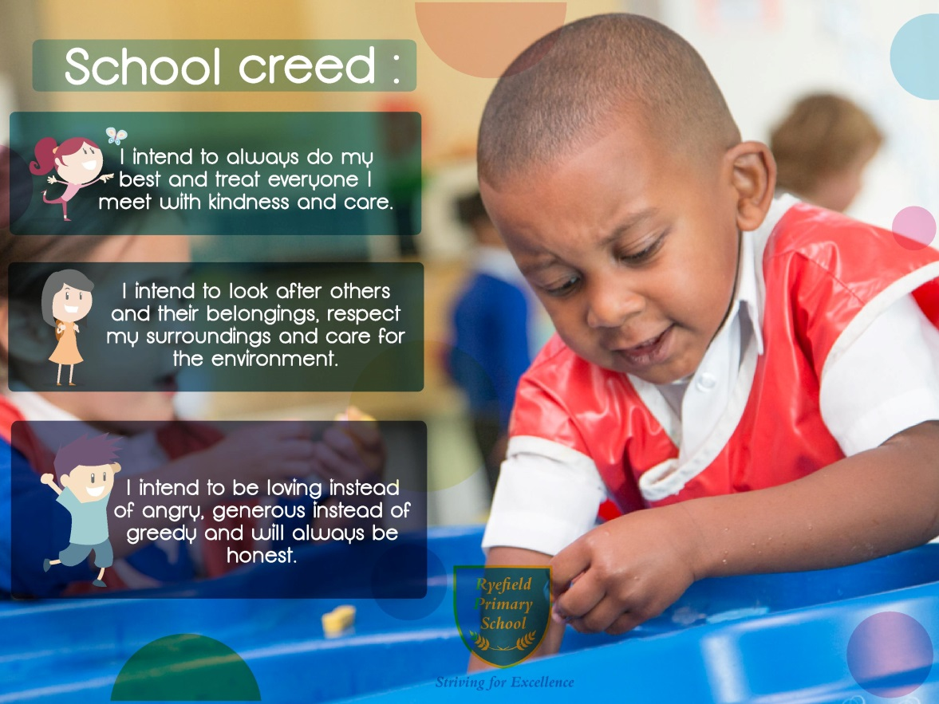

Ryefield’s expectations
These are shared with children at the beginning of every year, during assemblies and during P.S.H.E. Children are praised for following the school’s expectations

General
- Always look neat and tidy and wear school uniform
- Have respect for all people in school
- Always do as you are asked the first time
- Keep voices and behaviour in school at a quiet level
- Always be truthful and honest
- Take care of your possessions and those of other people

Movement
- Move quietly from room to room
- Walk on the left in corridors and on the stairs

Playground
- There should be no fighting or violent games – this includes play fighting
- Children should respect lines and boundaries at play and lunchtimes
- Children are not allowed on the grass around the playgrounds – the field may be used at certain times of the year with permission
- Children should not climb on benches or the sheltered areas
- Apparatus should be used with care and respect
- Children should not come back into the building without the permission of an adult
- All adults to be treated with respect
- At the end of playtime a whistle is blown, infants stand still and wait to be told to come in. Juniors have a second whistle which indicates they line up without talking and a third which indicates they come in silently
- When playing sports or games with others children should abide by the Fair Play 5 Rules:

KS1
  - I play friendly games.
  - I invite others to join in with my games.
  - I congratulate others when they have done well.
  - I am kind to people.
  - I am a good sport.
KS2
- I always listen to the referee or umpire and accept his or her decision without arguing.
- I always cheer on all of my team members in a positive way.
- If we win or lose I thank or congratulate the other team, and shake their hands.
- I always play to the rules.
- I am always polite to everyone I play with, including the opposition!

Assemblies
  - Children are to come without talking, listening to any music that may be playing
  - After being told to sit by their class teacher, children are to wait without talking for the assembly to start
  - At the end of the assembly the children wait quietly and lead out in an orderly manner
  - Children return to class and are dismissed by the teacher

PE Lessons
  - PE and games kit should be kept in school during the week (if a child does not have his/her PE kit they must visit the office so that a text can be sent to their parents)
  - Teacher’s instructions should be listened to carefully and followed straight away
  - Apparatus should be handled with care and only when a teacher is present

Dinner times
  - Children are to enter and leave the building when instructed in a quiet, orderly manner
  - Respect all dinner staff
  - Respect lunchtime monitors
  - Each table has lunchtime rules – which the children are reminded of regularly
  - Junior children and Infants come in as class names – children that miss their turn are sent to the headteacher to explain why
  - Conversation should be reasonably quiet, children leave the table after being dismissed by an adult, respect should be shown to all others and children should not change seats
  - Food should be arranged on the table and the lunch box placed carefully under the table. Uneaten food and empty packets should be placed in their own lunch boxes – empty drink cartons can be left in the bin. Bottles and cans should not be brought to school – ideally containers with a straw-size aperture should be used.

Broad principles - This is a reward based approach

Positivity is at the heart of behaviour management and here are the approaches that underpin this policy:
  - Staff model the standards of courtesy expected from the children
  - There should be consistent use of positive reinforcement ‘I am pleased to see….working quietly’
  - Every member of staff to praise in every lesson at least twice more than every reprimand, reprimands should be private rather than public.
  - Staff are to manage children’s behaviour in a calm, assertive manner. Don’t point fingers or appear aggressive
  - Rewards and sanctions are to be applied in a stepped, fair and consistent way
  - For serious incidents an investigation needs to be completed as soon as possible.
- If children are sent to the headteacher, or any other member of staff, they are given Reflection Sheets or apology templates to ensure they reflect on their actions

Rewards

  - Verbal Praise for following guidelines, golden rules, effort and achievement
  - House points issued for significant achievement, significant effort, contribution to the school community. Individual effort recognised with points certificates as below
The House that win the most times in a half term wear their house colour on the last day of that half term. House Points are recorded on a class chart.
  - Postcard Home/ Target sticker (HT) for academic achievement, when a child has achieved a target or outstanding learning/progress and the teacher would like this communicated home.
  - Merit Certificate (Achievement Assembly, CT) given for outstanding progress, effort, behaviour,
  - Behaviour Plate SMSA’s select pupils who have behaved well at lunchtimes
  - Headteacher’s Class Asset Award (End of Year Prize Giving) – Two children from each class are chosen for consistently good behaviour.

House Points | 50 | 100 | 150 | 200 | 250 | 300
 | Bronze Certificate | Silver Certificate | Gold Certificate | Platinum Certificate | Diamond Certificate | Letter Home

Behaviour checklist for teachers

Classroom
Know the names and roles of any adults in class.
Meet and greet pupils when they come into the classroom.
Display rules in the class - and ensure that the pupils and staff know what they are
Display the tariff of sanctions in class
Have a system in place to follow through with all sanctions.
Follow the school behavior policy

Pupils
Know the names of children.
Have a plan for children who are likely to misbehave
Ensure other adults in the class know the plan
Understand pupils’ special needs

Teaching

Ensure that all resources are prepared in advance

Praise the behaviour you want to see more of

Praise children doing the right thing more than criticising those who are doing the wrong thing (parallel praise)

Differentiate

Stay calm

Have clear routines for transitions and for stopping the class

Teach children the class routines

Ensure that you take the time to use class building and teambuilding exercises each week.

Parents
Give feedback to parents about their child’s behaviour - let them know about the good days as well as the bad ones

Behaviour Codes and Sanctions

Our code system ensures that we deal with any unacceptable behaviour in a consistent way across the school and that this will help the children to see that behaviour is dealt with fairly. It addresses the issue of low level disruptive behaviour which can occur, as this not only affects the learning of the person responsible but can also prevent other children from learning to best effect.

Within this policy is the Behaviour Codes and Rewards sheet, which shows the different levels of unacceptable behaviour for which a code may be given. It is used by all adults in school. We must emphasise that these are for guidance only, as we recognise each individual case and each child's needs, including special needs and behaviour plans, and personal context are taken into consideration. It is also impossible to describe every instance or type of misbehaviour and we will always listen to each child when dealing with incidents and try to unpick/investigate what has happened (which can take time).

The codes have been explained carefully to all of the children and they will be followed consistently across the school. When things go wrong and codes are given we discuss each child’s behaviour with them, help them to make amends and give them alternative strategies. Our aim is to help children to make the right choices and equip them with skills for life.

The codes summarised:
• A verbal code yellow warning is given for any of the code yellow behaviours.
• If this behaviour happens again during the session the child will be given a code yellow which will be recorded in a book in the classroom.
• If this behaviour happens again the child will be given a code blue which will be recorded. • If a child gets 5 separate code yellow in a week they will automatically be given a blue code.
• Code blue behaviours will not warrant a verbal warning as they are deemed to be very serious and often deliberate.
• Any child who is given a code blue will have to spend 30 mins at lunchtime in detention.
• During a detention the child will discuss their behaviour with an adult and complete an incident form which will be sent home to parents.
• Any child who gets a code blue three times in a half term will lose their special Be the Best time at the end of the half term.
• Any child given a code purple or red will be dealt with by a member of the senior management team and parents/carers will be informed straight away. This should be a rare occurrence.
• Each half term we start a fresh.

Other Sanctions
  - If a child does not return their homework their parents will be informed in writing and they will be expected to attend homework club during school lunchtime on a Thursday.
  - If a child forgets their PE kit their parents will be texted.
  - Proportionate, short detentions to complete unfinished work, at playtimes or lunchtimes.
  - School based community service may be used as a sanction e.g. Litter picking, tidying, and removing graffiti.
- Every class and playground has a “Making up Chart” where the children are taken and steps are followed to discuss minor problems in a calm and constructed manner.

Levels of Behaviour Management in school

Be the Best in the Early Years and Key Stage 1
Code | Student Behaviour | Sanction | Teacher Action | Extra Support
Green | Pupil respects the rights of others, is co-­‐operative and self-controlled |  | Positively reinforce behaviour – specific feedback e.g. encouragement, sharing success, responsibilities, red book, gold points. | Involve colleagues, parents and whole school in celebrating pupil achievement.
Yellow  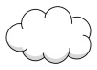 | Minor disruptions, talking, off task, interfering with other’s learning, making silly noises, repeatedly not following the uniform policy | Move positions on the carpet or classroom to be closer to the teacher.  To work in isolation during tasks – to work on the carpet rather than at their desk for example. | Teacher seeks supportive solution with student, negotiating small steps to success. Use of lunchtime detention to complete work if appropriate, reflect on disruption caused. Uses range of behaviour strategies (Appendix 1) | If necessary involve Year leader
Blue | Deliberate unkindness  Name calling or swearing  Deliberately misusing property Answering back or speaking rudely to any adult  Deliberately hurting others or being spiteful  Goading/winding others up Stealing from others  Lying  Deliberately ignoring any adult’s instructions  Behaving in a way that could cause harm to others, deliberately | Thinking Chair for 5 minutes followed by a reflective conversation with a teacher or teaching assistant.  Missing the first available playtime by standing on the Terrace. | Teacher consults with colleagues and informs parents. Monitor with behaviour/incident logs (Appendix 2) and continue range of strategies. | Involve support from Year and Phase leader, or SENco to define problem and assist in solution.
Purple  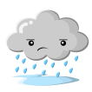 | Repeating code blue behaviour Physical/threatening aggression Severely disrupting lessons/bullying/swearing to insult/fighting/continually disrespecting adults/homophobic or racist name calling | Sent to the Year Group Leader to reflect on their actions and discuss a positive way forward.  Apology picture/card/letter to be drawn/written by the child – stating why they are sorry and what they will do better next time.  Parents to meet with teacher to discuss behaviour and agree sanctions and support at home. Discussions with parents to be recorded and kept at a central location.  Lose the Be The Best privilege or equivalent class treat such as Golden Time or Marble Party |  | Must involve SLT and parent to define problem and assist with solution.
Red | Repeating code purple behaviour Planned violence/abuse/major theft/vandalism/racism/homophobia/persistent bullying  Physical aggression or swearing to any member of staff | Parents and child to meet with Mr Tucker to discuss behaviour and options for support from home and school.  To work in another classroom for a morning or afternoon period.  Possible internal exclusion which may lead to an external exclusion. | Teacher refers the problems directly to SLT (senior leadership team). SLT will consider action in accordance with the appropriate policies, including the Restraint and Health and Safety policies. After discussion with pupil and parents an internal or fixed term exclusion may be considered. | Involve HT, parent and other agencies.

Be the Best in Key Stage 2
Code | Student Behaviour | Sanction | Teacher Action | Extra Support
Green | Pupil respects the rights of others, is co-­‐operative and self-controlled |  | Positively reinforce behaviour – specific feedback e.g. encouragement, sharing success, responsibilities, red book, gold points. | Involve colleagues, parents and whole school in celebrating pupil achievement.
Yellow | Minor disruptions, talking, off task, interfering with other’s learning, making silly noises, repeatedly not following the uniform policy | If you get five yellows in a week you will get a blue code and lunchtime detention for 30mins and you will complete an incident form. | Teacher seeks supportive solution with student, negotiating small steps to success. Use of lunchtime detention to complete work if appropriate, reflect on disruption caused. Uses range of behaviour strategies (Appendix 1) | If necessary involve Year/Phase leader, DH/SENco or AH to define problem and assist in solution.
Blue | Deliberate unkindness Name calling or swearing  Deliberately misusing property Answering back or speaking rudely to any adult  Deliberately hurting others or being spiteful  Goading/winding others up Stealing from others  Lying  Deliberately ignoring any adult’s instructions  Behaving in a way that could cause harm to others, deliberately | This is serious. You will be given a code blue if you already have a code yellow and repeat the same behaviour in a session. It will also be given for the following  For each code blue, you will have a 30 min lunchtime detention. You will fill out a incident form, it will be recorded and a letter will be sent home to your parents.  If you get three code blues in a half term you will lose Be the Best. You will also be put on a lunchtime or lesson time report card to monitor and encourage improvements in future behaviour. | Teacher consults with colleagues and informs parents. Monitor with behaviour/incident logs (Appendix 2) and continue range of strategies. | Involve support from Year and Phase leader, or SENco to define problem and assist in solution.
Purple | Repeating code blue behaviour Physical/threatening aggression Severely disrupting lessons/bullying/swearing to insult/fighting/continually disrespecting adults/homophobic or racist name calling | Internal exclusion: This is very serious. You will have to work for the whole day in another class.  The Headteacher and your parents will be informed and it will be recorded. You will lose a privilege and Be the Best.: |  | Must involve SMT and parent to define problem and assist with solution.
Red | Repeating code purple behaviour Planned violence/abuse/major theft/vandalism/racism/homophobia/persistent bullying  Physical aggression or swearing to any member of staff | This is extremely serious. The Headteacher and your parents will be informed and it will be recorded.  It will lead to an internal exclusion and may lead to an external exclusion. It will be given for the following: | Teacher refers the problems directly to SMT (senior management team). SMT will consider action in accordance with the appropriate policies, including the Restraint and Health and Safety policies. After discussion with pupil and parents an internal or fixed term exclusion may be considered. | Involve HT, parent and other agencies.

Recording Incidents

All behavior incidents must be logged and recorded in class/lunchtime behavior logs and any code blue or higher behavior on the school’s online monitoring portal CPOMS.
Exclusions are recorded in SIMs to provide an ongoing record of a child’s behaviour. This may be recorded on CPOMS also.
Behaviour is monitored and a termly report is produced for the governing body. The Chair of Governors and Local authority are informed. The Governing Body will review all permanent and certain fixed term exclusions. See the Exclusion of Pupils Policy for further details.

A punishment must be proportionate. In determining whether a punishment is reasonable, section 91 of the Education and Inspections Act 2006 says the penalty must be reasonable in all circumstances and that account must be taken of the pupil’s age, any special educational needs or disability they may have, and any religious requirements affecting them.

The school will consider whether the behaviour under review gives cause to suspect that a child is suffering, or is likely to suffer, significant harm. Where this may be the case, school staff will follow the schools’ safeguarding policy. They will also consider whether continuing disruptive behaviour might be the result of unmet educational or other needs. At this point the school will consider whether a multi-agency assessment is necessary.

Communication

Parents and Carers will be informed of positive behaviours through certificates, letters and postcards home. All initial communication about behaviour takes place between the class teacher and the parents/Carers. If behaviour is unacceptable i.e. lunchtime exclusion parents/carers will be contacted and invited where necessary to meet with the Team Leader and classteacher. Serious behaviour issues i.e. those that lead to internal exclusion will lead to the parents being invited to meet with the Deputy/Headteacher. Very serious behaviour issues which lead to external exclusions will be dealt with regard to current Government Guidance.

Bullying

All reports of bullying made to staff are treated seriously, please see the Anti-Bullying Policy and Equalities Policy. Children will be expected to complete an equalities incident report and sign an anti-bullying contract. All significant incidences of bullying will be recorded and reported to the Governing Body.

E-Safety

All reports of cyber bullying are taken seriously. As per our e-safety policy, pupils are regularly reminded about the impact of cyber bullying. Where cyber bullying has occurred outside of school, parents are informed and pupils are interviewed and reminded of expectations. Pupils and parents are offered support and advice via the Family Support Worker. Any pupil found to be using the DB website inappropriately, might be denied access to it.
Ryefield Primary School is also supported in this area via our Community Police Officer.

Malicious Allegations towards staff

In any situation where a malicious allegation has been made towards a pupil or member of staff, whether on or offsite, the school will take every measure deemed necessary to intervene and involve the relevant authorities.

School Uniform

It is also the responsibility of all staff to ensure that all children wear correct school uniform. Letters will be sent home to children who do not follow uniform guidelines.

Outside of school

The school expects a high standard of behaviour from pupils when in the community. The behaviour policy applies off-site when travelling to and from school, or on school trips.

Home School Agreement

All parents are encouraged to sign a Home-School Agreement which covers issues such as homework, behaviour and e-safety.

Behaviour Mentor and Support

When a child continuously displays inappropriate behaviour, or is consistently breaking the rules, they are referred to Ryefield’s Behaviour Mentor. They are asked to meet with the designated staff member at the end of lunchtime (for an initial period of two weeks) to discuss their day and any incidents that may have happened. This has been set in place not just to monitor the behaviour of the child, but also to encourage and nurture positive behaviour for the future. The current designated staff member is Michele Dell in Welfare.

The School welcomes our duties under the Equality Act 2010 to eliminate discrimination, advance equality of opportunity and foster good relations in relation to age (as appropriate), disability, ethnicity, gender (including issues of transgender, and of maternity and pregnancy), religion and belief, and sexual identity. We will take full account of our duties to those pupils with disabilities when considering the support provided for and sanctions issued to pupils.

Use of reasonable force

School staff have the legal power to use reasonable force on pupils. This is used either to control or restrain. It must be no more than is needed in the circumstances to prevent a child from hurting themselves or others, from damaging property, or from causing disorder

Other

There are other policies that may be read with this document, notably the Positive Handling Policy and Anti-Bullying Policy and E-Safety Policy.

Appendix 1

Non Verbal Cueing

Non verbal cues are a quick and effective way to raise a pupil’s behavioural awareness. This could be pointing to your ears to indicate a group should be listening or holding up an open hand to indicate that the teacher would like a groups or classes attention. NB – when using cues it is important to be aware of emphasising or gesticulating in a non-­‐threatening way (not pointing or tapping on a table for example).

Immediate consequences

Examples include:

-­‐ sitting away from others (after repeatedly distracting fellow pupils)
-­‐ working away from others (relocation in the room)
-­‐ cool off time within the room.
-­‐ time out, away from the activity or classroom.

Deferred consequences

Deferred consequences range from the ‘chat after class’, through to a lunchtime detention. A deferred consequence such as a detention should relate to the behaviour, e.g. finishing off work, or drawing pictures / describing what went wrong and how to fix it.

Following up

Some behaviour issues can be followed up after class. This may include cleaning/packing up in own time or finishing work during lunch and then follow up the behaviour one to one with the pupil.
When following up consider:
-­‐ ‘calm’ self before calming the pupil.
-­‐ tune in to how they may be feeling.
-­‐ avoid ‘rushing’ the dialogue.
-­‐ use open body language and avoid crowding personal space.
-­‐ avoid arguing; keep the focus on the behaviour/issue.
-­‐ adopt a pleasant tone.
-­‐ refer the pupil to the class agreement or rule that has been broken.
-­‐ allow the right of reply.

This may also involve a ‘negotiated consequence’ where the teacher and pupil agree an appropriate resolution / restitution for the situation.

‘I’ statements

These can be used to convey the teacher’s needs and concerns or to tune in to the pupils needs and concerns: ‘I can see you’re upset, is it because...’ or ‘I feel concerned/worried/upset, that you are...’
It may also be directional
‘I want you to put your hand up without calling out’ or ‘I want you to go back to your seat and work...’

Safe Touch

Touch on the upper arm/shoulder to affirm an instruction or to provide physical reassurance.

More than ‘catching them being good’

Children with high attentional needs and distracting, disturbing attentional behaviours also need to be taught how to gain fair and appropriate attention. To do this we need to directly teach them alternative patterns of behaviour and social skills. With all children we need to be aware of ensuring we have communicated in the best way for them e.g. discussion, modelling, drawing, social stories etc.

Covid 19 - Addendum to Behaviour Policy - Coronavirus - June 2020 Students who breach the new guidelines, set out in the home school agreement in particular social distancing rules, may be sanctioned in line with school policy in terms of defiance and/or reckless behaviour. (See Appendix 3)
This ​includes but is not limited to students who make inappropriate comments, orally or in writing, and/or behave un-co-operatively. The sanction will depend on the degree of the breach, e.g. potential risk caused to themselves and others, and willfulness of any individuals involved. For significant infringements, students may be instructed to work remotely for a period of time as part of the sanction as well as receiving an exclusion.

Appendix 2 – This log is to assist in identifying patterns, trends and triggers in behavior.

Ryefield Primary School – Behaviour Log
Name Class
Date | Time | Behaviour | Sanction

Appendix 3

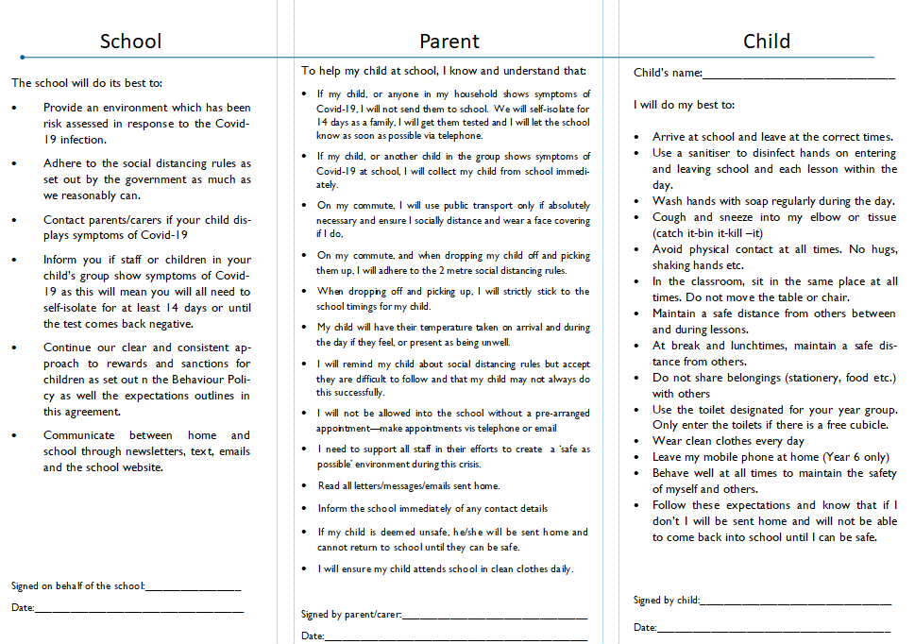

Review Framework

Revision History

Date of this revision: November 2019
Date of next revision: November 2020

The policy should be reviewed annually (or sooner in the event of revised legislation or guidance)

Revision date | By | Summary of Changes Made

Approval

Name | Signature | Title | Date of Issue | Version

