Ryefield Primary School

Special Educational Needs and/or Disabilities (SEND) Information Report
Questions and answers for parents and carers

- Who are the best people to talk to at Ryefield School about my child’s difficulties with learning, special educational needs or disability?

In the first instance, it is always best to talk to your child’s class teacher about your concerns.
It is likely that the class teacher will have discussed your concerns with the school SENCO (Special Educational Needs Coordinator). At Ryefield School, our SENCO is Mrs Hayward. You may wish to arrange a meeting with her.
If you continue to have concerns, you may wish to arrange to discuss these with a member of the Senior Leadership Team: Miss Woodbridge for Nursery/Reception and Years 1 and 2 or Mr Murray for Years 3-6.
This Photo by Unknown Author is licensed under CC BY-ND

- How will the school let me know if they have any concerns about my child’s learning, special educational needs or disability?

Your child’s class teacher may initially speak with you at the beginning or the end of a normal school day and/or arrange a further time to discuss the concerns.
The class teacher may also talk to you about any issues at a parent/carer consultation meeting (these are held three times a year during Open Evenings).
The SENCO or another member of the leadership team may contact you and arrange a meeting to discuss your child’s difficulties with learning and any possible support strategies the school might be considering.
If the school are concerned about your child’s learning, special educational
needs or disability and are putting in some form of support to help your
child access their learning, then the school will contact you to tell you
about this support.

- How will the school consider my views and those of my child with regard to her/his difficulties with learning, special educational needs or disabilities?

At Ryefield School we believe it is very important for parents/carers to be involved in all areas of their child’s learning and we actively encourage discussions. We believe, where appropriate, that your child’s views on any difficulties they may experience with their learning form an essential part of the process.
You will be able to share your views and discuss your child’s progress at regular meetings with the class teacher or other professionals.
If your child has an identified special educational need you will be invited to meet with your child’s class teacher to discuss strengths, areas for development, current progress, support strategies being used and expected outcomes. The SENCO may be involved in some of these meetings.
If your child has an Education, Health and Care Plan (EHCP), you and your child will both be encouraged to share your views at the Annual Review meeting with the class teacher, support teachers and SENCO.

- How does Ryefield School ensure the teaching staff are appropriately trained to support my child’s special educational needs and/or disability?

At Ryefield School, your child’s learning needs will first be met
through the high-quality teaching delivered by her/his
class teacher.
This will include a quality assessment of your child’s needs, planning
to meet these needs and an evaluation of strategies and their
success in supporting your child to do their best.
The school staff (teaching and support staff), participate in a wide
range of continual professional development to ensure there is the
appropriate expertise to support children with SEND.
The school uses expertise from professionals within the school,
advice and support from professionals from outside organisations
and providers and accesses a wide range of external training
opportunities.
These include:
  - LBH Hillingdon Children’s Integrated Therapy Services – including Speech and Language Therapy, Occupational Therapy and Physiotherapy
  - LBH Hillingdon Inclusion Team
  - Educational Psychologist (privately sourced)

In response to particular needs, individual training is arranged where
necessary.

- How will the curriculum and the school environment be matched to my child’s needs?

At Ryefield School, we believe that your child’s learning needs will first be met through the high quality teaching delivered by her/his class teacher, who takes responsibility for planning an appropriate curriculum offer for your child.
We carefully plan our curriculum to match the age, ability and needs and interests of all children.
The class teacher will, whenever necessary, adapt lesson planning and teaching to match your child’s special educational needs and/or disability.
It may be appropriate to adopt different strategies, use specific resources and adapt outcomes to meet your child’s learning needs and ensure they are successful.
Additional specialist advice is sought when appropriate and, when necessary, accessibility aids and technology may be used to support your child’s learning.
Ryefield School regularly reviews its Accessibility Plan to ensure that all children have the fullest access to the curriculum and the school site as possible.
All classrooms at Ryefield School are accessible for children with physical needs and disabilities. There is a lift to ensure access to the first floor classrooms, ICT suite and Science room.
Large classrooms enable disabled access to be offered for wheelchair users.
The school is able to make adaptations to the environment to cater for the needs of children with visual or hearing impairment.
The school provides a range of specialist resources which can be used to adapt and enrich the curriculum for children with SEND. These include resources for the development of fine and gross motor control, resources to support speech and language, a range of games to support emotional and social needs and practical materials to support learning needs.

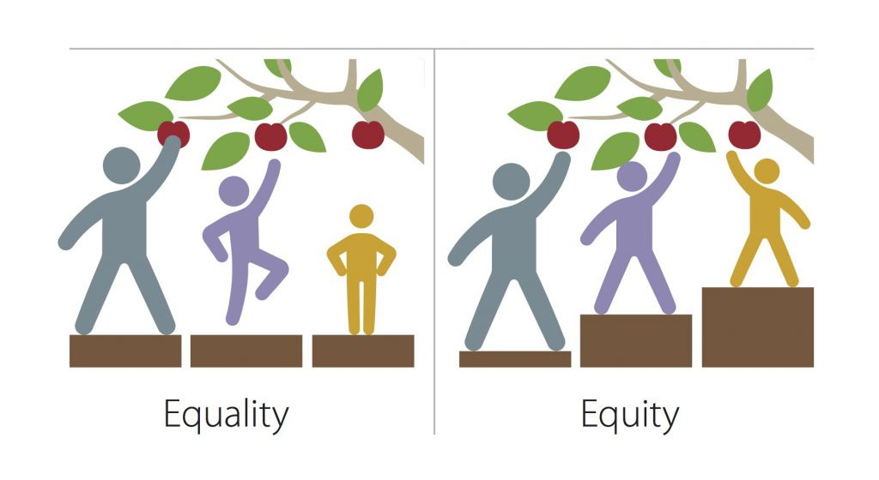

- What types of support may be suitable and available for my child?

The school has a range of resources and support to offer. These
are used to respond to the specific nature of the needs and
difficulties that your child experiences with learning. We want to
work with you to ensure that our education provision matches
the needs of the four broad areas of need, as defined in the SEN
Code of Practice 2014;

- Communication and interaction
- Cognition and learning
- Social, emotional and mental health
- Sensory and/or physical needs

At Ryefield School, we have a 3 tiered approach to supporting a child’s learning.

- Universal – this is the quality first teaching your child will receive from her/his class teacher and may include some very minor adaptations to match learning needs.
- Targeted – it may be appropriate to consider making additional short term special educational provision to remove or reduce any obstacles to your child’s learning. This takes the form of a graduated four-part approach of a) assessing your child’s needs, b) planning the most effective and appropriate intervention, c) providing this intervention and d) reviewing the impact on your child’s progress towards individual learning outcomes. Specific targeted one to one or small group interventions may be run outside the main classroom. These will be limited to a number of weeks to minimise disruption to the regular curriculum. You will be kept informed of your child’s progress towards learning outcomes by the class teacher.
- Specialist – it may be necessary to seek specialist advice and regular long term support from a specialist professional outside the school in order to plan for the best possible learning outcomes for your child. This may include Speech and Language Therapy, Occupational Therapy, Sensory advisory teachers from the Hillingdon Inclusion Team, the Child and Adolescent Mental Health Service (CAMHS) and the Child Development Centre (CDC) service. The school may need to prioritise referrals to these services. However, for a very small number of pupils access to these specialists may be through an EHC Plan.

The current interventions provided at Ryefield School
include:

Hub Speech and Language sessions
Hub Bucket time - attention and listening sessions
Hub Social Communication Skills sessions
Precision Teaching Sight Word sessions
Spelling Shed support
Beanstalk volunteer readers
Literacy Small Group, teacher-led sessions
Hub SEMH touch base sessions
Family Support Adviser – supporting environmental factors
Art Club - lunch time wellbeing sessions
Maths Breakfast booster sessions
Lexia - Reading and Spelling online tuition programme
Third Space Learning - Maths online tuition programme
MyMaths - online tuition programme

- How will you support my child to reach his/her learning outcomes?

A learning outcome is a target, usually set by the specialist involved with your child’s support. Outcomes link to what we wish to see children doing by a certain time – ‘holding a conversation with their peers for 5 minutes,’ ‘producing a page of work using clear , legible handwriting,’ ‘independently getting the resources needed for a task,’ for example. The class teacher and other staff working with your child, ensure that your child receives appropriate teaching and support in order to reach their learning outcomes. Strategies and progress will be reviewed regularly (at least termly), in response to your child’s needs.
External agencies and specialists may also be involved in the review of your child’s progress and inform planning accordingly.
At Ryefield School we believe that parents/carers and children are at the centre of any provision that is made to support a child with their learning outcomes. We want to work with you to ensure that your child makes the best progress.

This Photo by Unknown Author is licensed under CC BY-NC-ND

- What is an EHC Plan and who can request one for one for my child?

The purpose of an Education, Health and Care Plan (EHC Plan or EHCP) is to make special education provision to meet the complex, special educational needs of a child or young person, to secure improved outcomes for him/her across education, health and social care and, as he/her gets older, prepare for adulthood.
An EHC Plan will contain:
the views and aspirations of you and your child,
a full description of his/her special educational needs and any health and
social care needs,
establish outcomes for your child’s progress,
specify the provision required and how education, health and social care will
work together to meet your child’s needs and support the achievement of
the agreed outcomes.
One of the main criteria for an EHCP, is that more
than £6000 is needed for a pupil to access daily mainstream classroom
education. You, as parent/carer, or the school can request that the local
authority conduct an assessment of your child’s needs. This may lead to an
EHC Plan.

- How will you help me to support my child’s learning?

We will provide you with home learning to help your child make the best possible progress, offering you support if you need this.
In addition, we will offer suggested strategies or activities for you to do at home to support your child’s learning and meet their needs.
We sometimes run parent/carer workshops in school to help you understand the strategies used in school. In addition, we may be able to offer you individual training in specific support strategies relevant to your child.
If your child has an identified special educational need, you will be invited to meet with your child’s class teacher as often as requested, to discuss strengths, areas for development, current progress, support strategies being used and expected outcomes. The SENCO may be involved in some of these meetings.
The SENCO, SEN Support Adviser or Family Support Adviser can also support you with strategies, resources and ideas for supporting your child’s learning at home.
You may have an opportunity to meet with other professionals involved in supporting your child, i.e. Educational Psychologist, Speech and Language Therapist, Occupational Therapist, etc.
We actively encourage parents and carers to approach us if they feel more
support is needed. This is a partnership.

This Photo by Unknown Author is licensed under CC BY-SA

- How is support allocated to children and how do they move between the different levels of support in school?

Ryefield receives funding from the Local Authority. These funds include money to support the learning of children with SEND.
The Head Teacher, in consultation with the school Governors, decides the budget for SEN provision on the basis of the needs of the children in the school.
The Head Teacher, the Senior Leadership Team and the SENCO discuss
the effectiveness of the school’s current interventions and provisions
and prioritise any additional or alternative interventions, staff
training and equipment needs.
This process is reviewed regularly to ensure the best possible
Provision is in place for those children who require additional
support to access learning.

- How will the school know that the support has made a difference to my child’s learning and how can I and my child be included in this review process?

Your child’s progress will be assessed both in terms of his/her regular learning within the class and with regard to specific intervention programmes.
The impact of the support given is carefully measured to ensure that the learning outcomes have been achieved and if not, what adaptations are necessary. It may be decided that a further period of support would be beneficial for your child.
You and your child will be kept informed and encouraged to be actively involved at all stages of this support.

- What support will there be for my child’s happiness and wellbeing at Ryefield School?

At Ryefield we believe that the happiness and wellbeing of all our pupils is paramount. All members of staff take this aspect of school life very seriously.
You can be confident that in particular your child’s class teacher, the teaching assistants, the SENCO and other Ryefield staff all aim to provide support to match your child’s needs.
You should also feel free to contact your child’s class teacher if you have any concerns.

This Photo by Unknown Author is licensed under CC BY-SA

- How is my child included in all the same activities as his/her peers at school?

Ryefield is an inclusive school and committed to providing equal opportunities for all children.
School clubs, before and after school provision, educational visits and residential trips are available to all children.
When necessary, the school will make reasonable adjustments to ensure that children with SEND are included in all activities.
You should also feel free to contact your child’s class teacher if you have any concerns or important pieces of information.

- How will Ryefield School support my child during transition stages?

If your child has SEND, we liaise closely with the school or nursery your child is transferring from. We are able to discuss with the relevant teachers any individual needs and how best to support your child when they join Ryefield.
While your child is at Ryefield, we will take care to ensure that during transition points (between classes each year and at the end of Key Stages) all staff are aware of individual pupils needs, learning progress and best support strategies. Handover meetings are conducted at transition points for smooth and thorough liaison to take place between staff members. Your child will have opportunities to spend time with new staff to ensure continuity and to build a rapport.
We make arrangements to ensure there is a smooth transition when your child transfers to his/her secondary school of choice.
If your child has an EHC Plan, we will participate and/or facilitate its
review in sufficient time prior to him/her moving between key phases of
education. You will be kept informed of these arrangements and asked to
attend the reviews. Reviews will take place at a date and time which suits
all attendees including parents/carers.

- If I have any other questions about my child at Ryefield, who can I ask?

At Ryefield we are very happy to speak with you about any aspects of your
child’s education or wellbeing. It is best to speak to one of the following
staff members in this order:
Your Child’s Class Teacher
The SENCO – Mrs Hayward
A member of the Senior Leadership Team – Miss Woodbridge, Mr Murray or
Mrs Strong (Deputy Head Teacher)
The Headteacher – Mr Tucker

Ryefield Primary School – Assess, Plan, Do, Review Cycle

